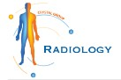

Discovering the Benefits of Ultrasound Services at Crystal Radiology. (02) 8315 8292

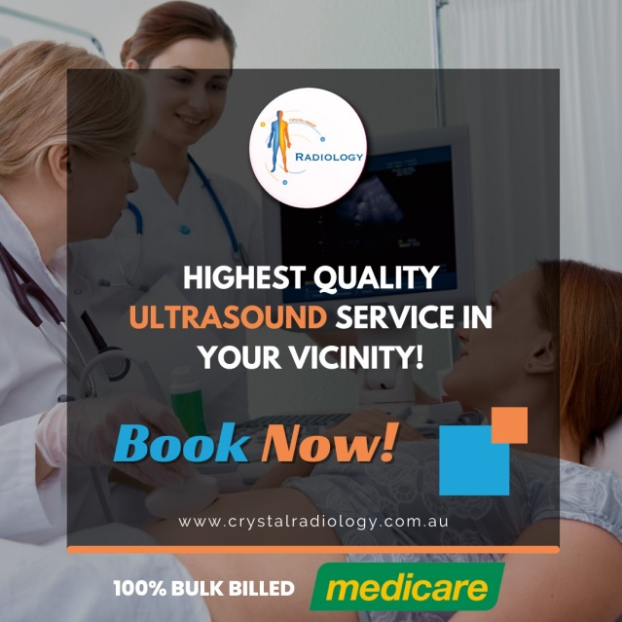**Introduction:**

Welcome to Crystal Radiology, your trusted destination for advanced medical imaging services. In this guide, we'll explore the world of ultrasound and how it can benefit you at our state-of-the-art facility. Let's delve into the basics of ultrasound, its uses, and why [**Crystal Radiology**](https://crystalradiology.com.au/ultrasound/) is your ideal choice for ultrasound services.

**What is Ultrasound?**

Ultrasound is a non-invasive imaging technique that uses high-frequency sound waves to create real-time images of the inside of your body. Unlike [**X-rays or CT scans**](https://crystalradiology.com.au/ultrasound/), ultrasound does not involve radiation, making it safe for various medical purposes.

**Why Choose Crystal Radiology for Ultrasound?**

We are local and a family-owned medical clinics that offers the highest quality medical and Imaging Services in the Crystal radiology region. We are the leaders in Bulk Billing with the real benefit of no ‘Out of Pocket’ expenses for you.

* **Expertise:** Our team of experienced [**sonographers**](https://crystalradiology.com.au/appointment/) and radiologists specializes in ultrasound imaging, ensuring accurate and detailed results.
* **Advanced Technology:** We use the latest ultrasound equipment, providing high-resolution images for precise diagnosis.
* **Comprehensive Services:** From obstetric ultrasounds for expectant mothers to abdominal and pelvic ultrasounds, we offer a wide range of ultrasound services.
* **Comfortable Environment:** Our modern facilities are designed with your comfort in mind, ensuring a pleasant [**experience**](https://crystalradiology.com.au/appointment/) during your ultrasound exam.

**Uses of Ultrasound at Crystal Radiology:**

* **Obstetric Ultrasound:** Monitor the health and development of your baby during pregnancy with our obstetric ultrasound services.
* **Abdominal Ultrasound:** Evaluate organs such as the liver, kidneys, [**gallbladder**](https://crystalradiology.com.au/harris-park-radiology/), and pancreas for abnormalities or diseases.
* **Pelvic Ultrasound:** Assess the pelvic organs, including the uterus, ovaries, and bladder, for conditions like cysts or tumors.
* **Musculoskeletal Ultrasound:** Examine muscles, tendons, ligaments, and joints for injuries, inflammation, or [**degenerative**](https://crystalradiology.com.au/granville/) changes.
* **Vascular Ultrasound:** Evaluate blood flow and detect blockages or abnormalities in blood vessels, aiding in the diagnosis of vascular conditions.
* **Thyroid Ultrasound:** Assess the thyroid gland for nodules, cysts, or other thyroid disorders using ultrasound imaging.

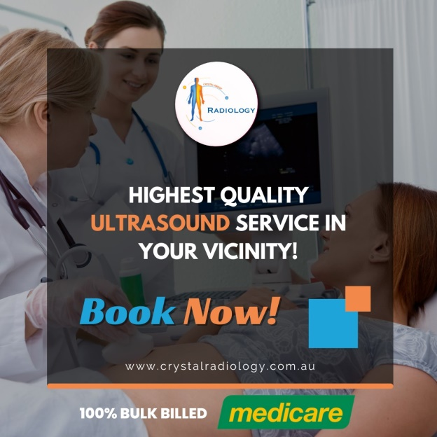

**Benefits of Ultrasound Services:**

* **Non-Invasive:** Ultrasound imaging is painless and non-invasive, requiring no incisions or radiation exposure.
* **Real-Time Imaging:** Obtain [**immediate**](https://crystalradiology.com.au/auburn/), real-time images during the ultrasound exam, allowing for on-the-spot diagnosis and assessment.
* **Safe for All Ages:** Ultrasound is safe for people of all ages, including pregnant women and children.
* **Guided Procedures:** Ultrasound can be used to guide minimally invasive procedures such as biopsies or fluid aspirations with precision.
* **Cost-Effective:** Compared to other imaging modalities, ultrasound is generally more affordable, making it accessible for routine screenings and diagnostic purposes.

**Conclusion:**

At Crystal Radiology, we prioritize your health and well-being by offering comprehensive and high-quality ultrasound services. Whether you need an obstetric ultrasound to monitor your baby's growth or a [**musculoskeletal**](https://crystalradiology.com.au/butler-imaging/) ultrasound to assess joint pain, we are here to provide accurate imaging and personalized care. Trust us for your ultrasound needs and experience the difference in diagnostic excellence at Crystal Radiology.



**Ready to schedule your ultrasound appointment?**

Contact us today at [**(02) 8315 8292**](https://crystalradiology.com.au/appointment/) or visit our website **(www.crystalradiology.com.au)** to learn more about our ultrasound services and book online. We look forward to serving you and ensuring your health journey is smooth and informed.

**Our Service Locations:**

**Harris Park Radiology Granville Radiology**

|  |
| --- |
| Phone: (02) 7809 0804 |
| Email: info@granvilleradiology.com.au |
| Address:165 Clyde St, South Granville NSW 2142, Australia |
| Website: www.granvilleradiology.com.au |

|  |
| --- |
| Phone: (02) 8897 8686 |
| Email: info@harrisparkradiology.com.au |
| Address: 65 Harris St, Harris Park NSW 2150, Australia |
| Website: www.harrisparkradiology.com.au |

|  |
| --- |
| Phone: (08) 9544 3999 |
| Email: info@butlerimaging.com.au |
| Address: Shop 29/150, Camborne Pkwy, Butler, WA, 6036 |
| Website: www.butlerimaging.com.au |

**Auburn Radiology Butler Medical Imaging**

|  |
| --- |
| Phone: (02) 8315 8292 |
| Email: info@auburnradiology.com.au |
| Address:101/39 Queen St, Auburn NSW 2144, Australia |
| Website: www.auburnradiology.com.au |